MovieQ - Software Design Description - **BLUEPRINT for Project**

**6.1 Introduction**

This document presents the architecture and detailed design of the MovieQ database project. The project will initialize and store data inside of 3 different database engines: PostgreSQL, Cassandra, and Elastic Search. Each of the databases will be run from my computer and the data inside of them will be imported from the same dataset. I will query each database to see which one is the fastest.

6.1.1 System Objectives

The objective of this project is to run 3 databases side-by-side and see the strengths and weaknesses of each. The project will be able to highlight the differences between the underlying architecture of each database, SQL or NoSQL. It will also teach me about the different query languages that each database engine uses. Finally, we want to see which one is able to query the fastest and has the best performance out of all 3 of them.

6.1.2 Hardware, Software, and Human Interfaces

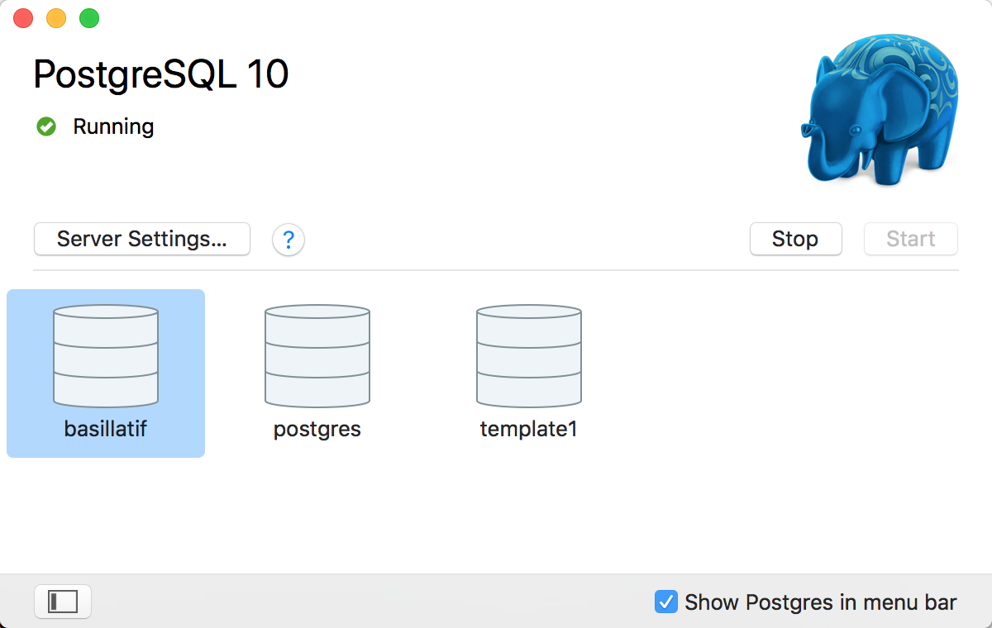

**Postgre initial page**

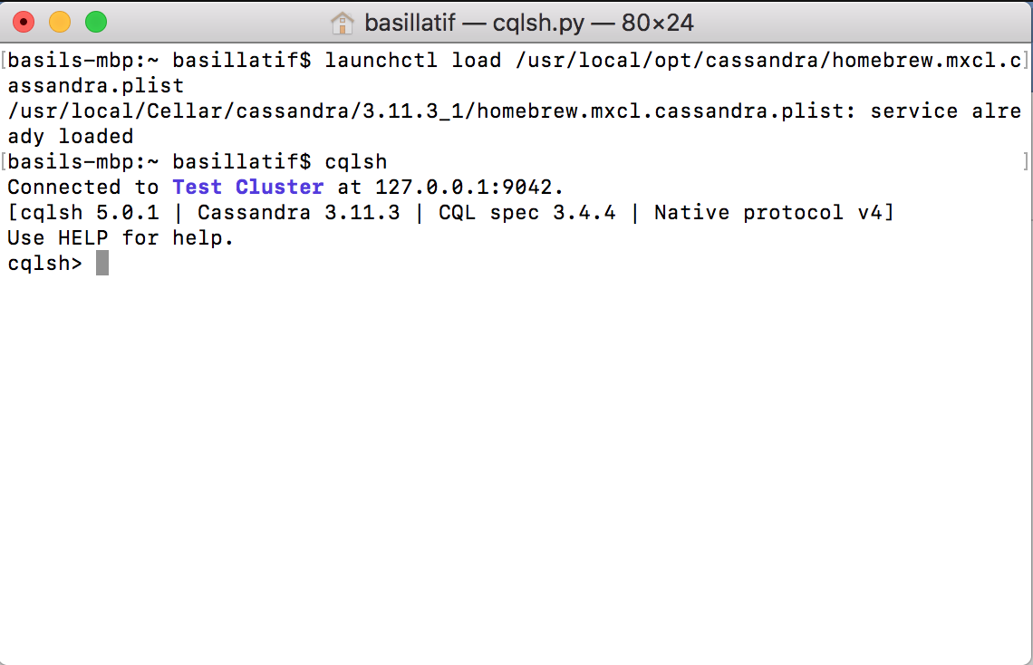

**Cassandra Shell on My Laptop**

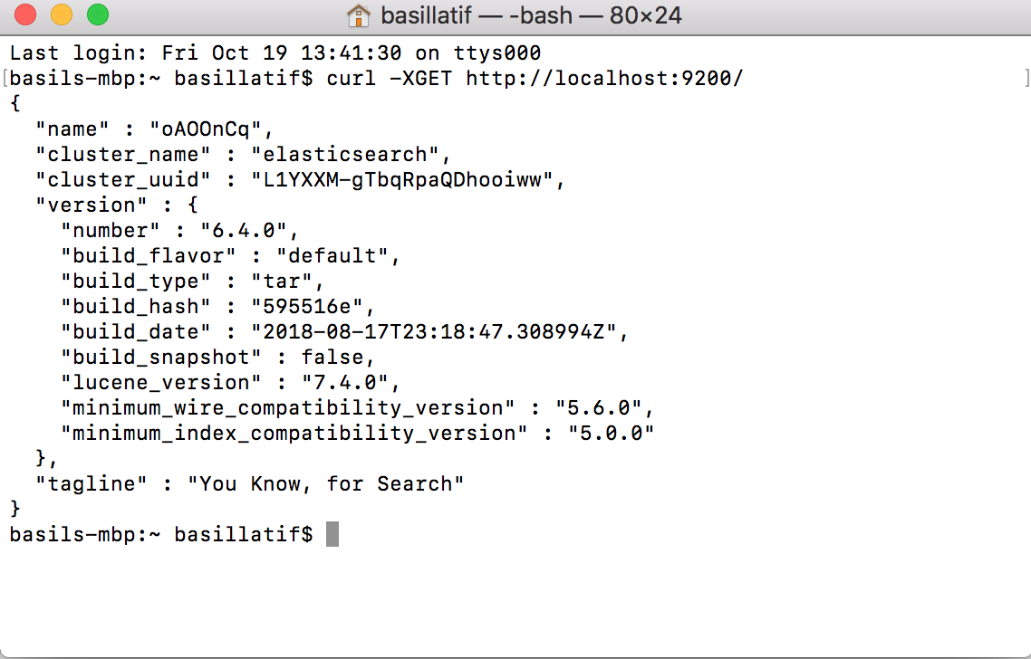

**Elastic Search on Command Line**

**6.2 Architectural Design**

<<Have a diagram like the one he drew on the board>>>

6.2.1 Major Software Components

PostgreSQL

The GUI for PostgreSQL will be completely functional and be able to run complex SQL queries.

Cassandra DB

Cassandra will be accessed on the command line and will be able to run CQL queries.

Elastic Search

Elastic Search will be available on the command line and able to do analytics on the data.

6.2.2 Major Software Interactions

None.

6.2.3 Architectural Design Diagrams

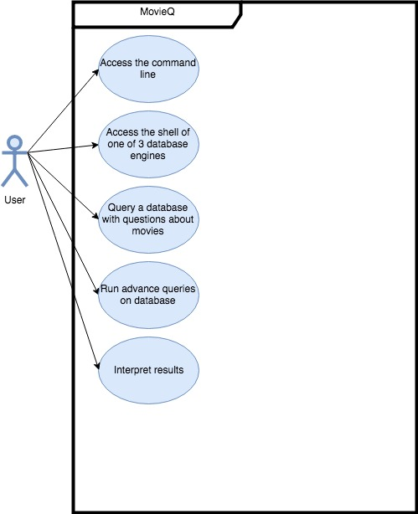

**Use Case Diagram for MovieQ**

**<<2 more>>**

**6.3 CSC and CSU Description**

The Computer Software Components and Computer Software Units of the application follow from the initial setup after the data has been imported into the 3 separate engines.

**6.4 Database Design and Description**

6.4.1 Database Design ER Diagram Section

A screenshot of a cell phone


**ERD Diagram for Ratings Of Each Movie**

6.4.2 Database Access Section

The project will have to deal with the fact that our dataset is inside a csv file. We have to properly import the csv files either through an interface provided by each database engine or some other way. Below I have outlined how this will happen in each database.

A screenshot of a cell phone


How to Import a CSV into PGAdmin for use with PostgreSQL

A screenshot of a computer


**Tutorial for How to Import CSV into Casasandra**

A screenshot of a social media post


**Indexing a CSV File with Elastic Search Ingest Node**

6.4.3 Database Security Section

No additional security beyond that which is built into my OS will be provided.